**Directions for Using Behavior Classifier**

Please contact Ben Habermeyer at [benhabe@seas.upenn.edu](mailto:benhabe@seas.upenn.edu) | 434-242-6984 with any questions

Important notes: This code assumes that you are using a 3 rows x 4 columns set of wells for a total of 12, though some may be manually excluded from analysis, and 2 flies per well. The video should be of good quality (ex. not shaky) and should be in its own folder to start.

The code is located in users/bmain/PyCharm projects/Behavior classifier on the lab computer. To run, simply open the project BehaviorClassifier.py in pycharm, and press the green triangle to go.

Step 1. Select a video to be classified. A filesystem GUI will ask the user to select a video to be processed. Select the video and press “open”. All subsequent data produced in the analysis will be placed in this folder where the video is located.

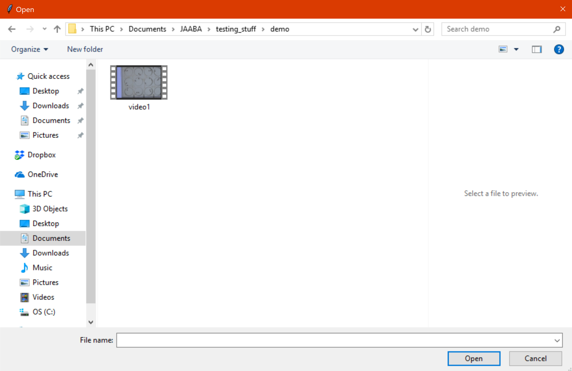

Step 2. Crop the video. The user will be prompted if they would like to crop the video. If they would, a second prompt appears asking for the time in seconds which they would like the video to start and end cropping. This process writes a new video mp4 with the additional name _cropped and creates a subfolder within the original video’s folder called “uncropped video” which will house the old video, should you ever need it again. If you want to crop the video before its actual end, just place the time in seconds you would like the cropping to end in the second box.

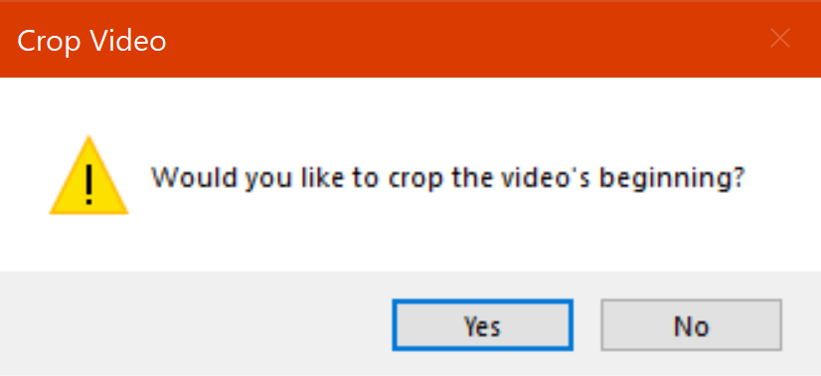

Example cropping first 15 minutes of the video

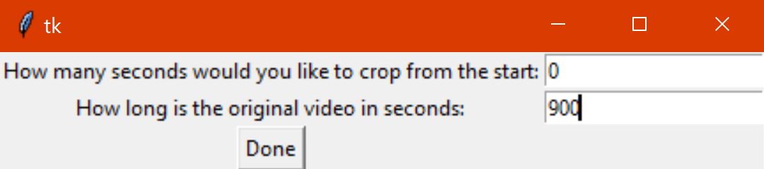

Step 3. Calibrate the video. FlyTracker Calibrator will then launch in MATLAB. This is divided into a few steps

Select the well dimensions by dragging the line segment across one well and setting this to be 16mm in diameter.

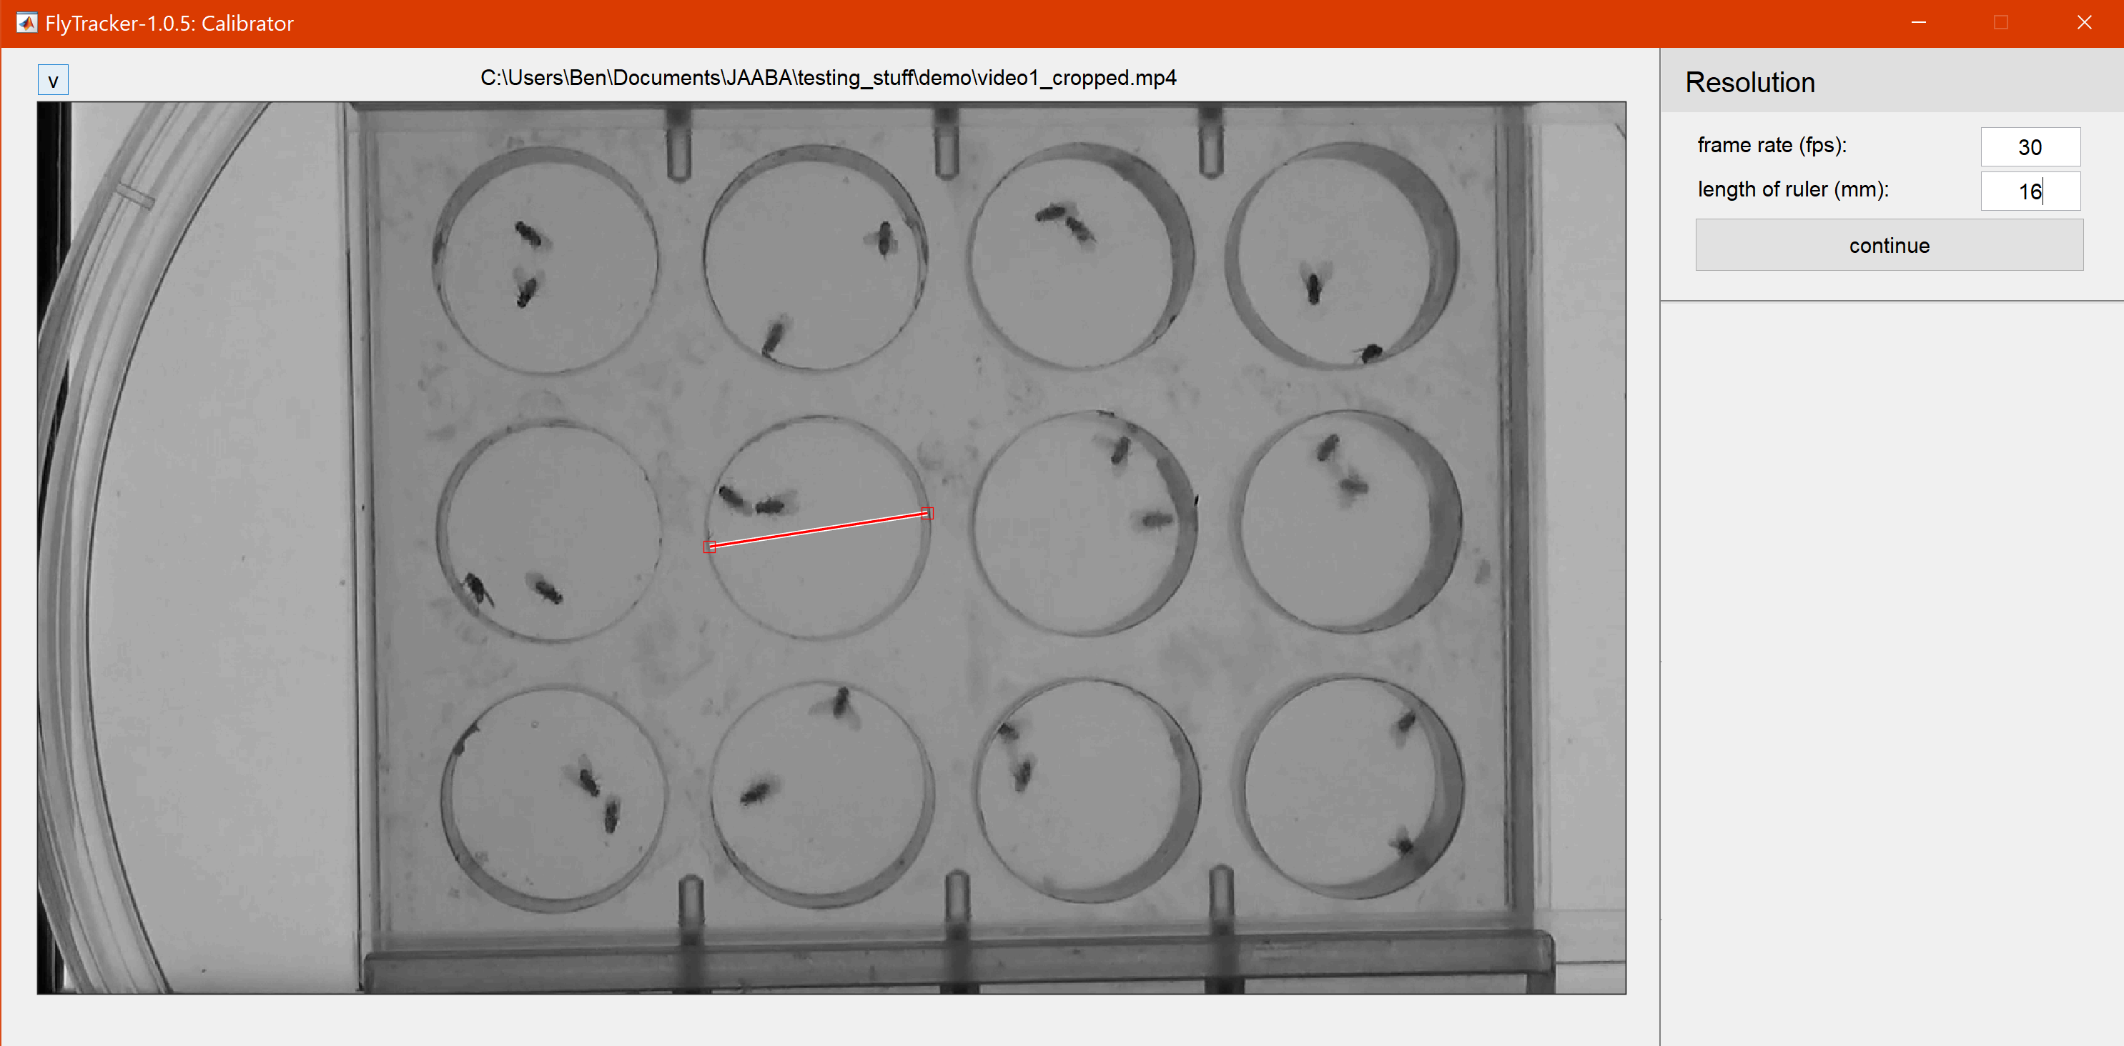

Then select the wells themselves. If you are tracking all 12 wells, you can do this automatically. If any wells need to be excluded, or if the automatically-found wells do not look appropriate, then you will need to manually set the well positions. Do this by selecting manual from the dropdown, then set the shape to circles, set the number of wells, and set the number of flies to 2. Then change the diameter of all the circles by dragging points on the upper left blue circle. Only put wells over wells whose flies you would like to track.

Rules of thumb for this step: Make the diameter of the well ~<16mm, with circles set just inside of the wells (to avoid the dark well edges as much as possible). This step is very important for videos with dark wells, as they can sometimes be classified as the fly during tracking, so make sure to exclude the rim of the wells. Make sure the number of flies is 2! An example is provided below – notice how the circles are positioned just inside the wells.

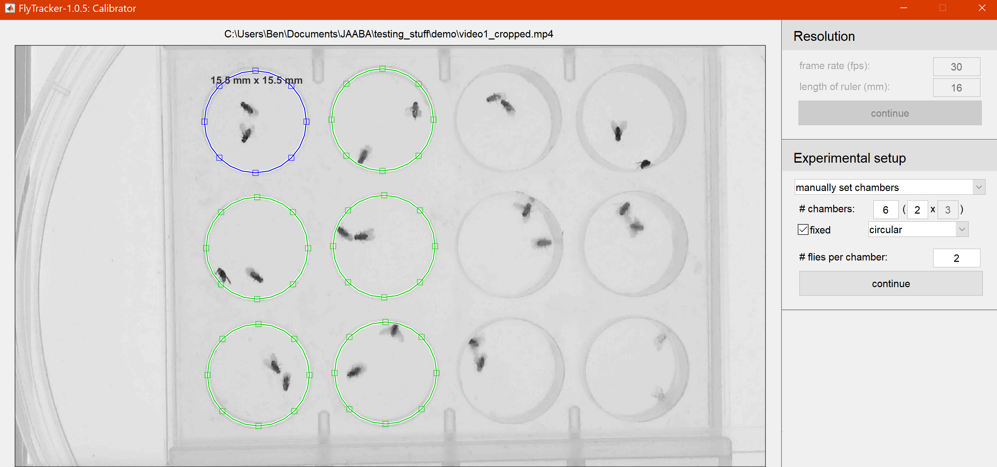

When to exclude a well – when the background subtraction in the calibration step looks poor, either from the fly not moving much, there only being 1 fly in the well, or from a blurry well, that well should be excluded. Example of a poor well:

Finally set the foreground and background thresholds. For the foreground threshold, make the threshold high enough to recognize the wings of the flies in blue, but not high enough such that parts of the background that are not the fly are classified as being part of the fly. For the body threshold, the classifier works best with a body threshold of 0.5-0.7.

A good example:

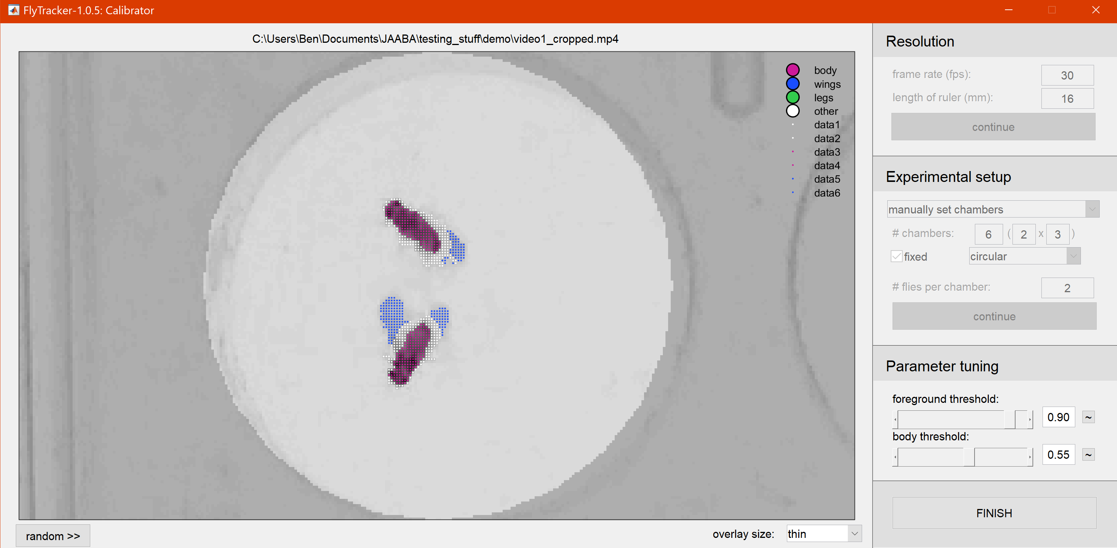

Step 4. Accept calibration. This step is a QC on the calibration step in case there were any surprises. This could happen if a fly died, did not move, or the well was blurry hence the background subtraction for that well looked bad. In this case, it “no” and re-do step 3. Otherwise hit “yes”.

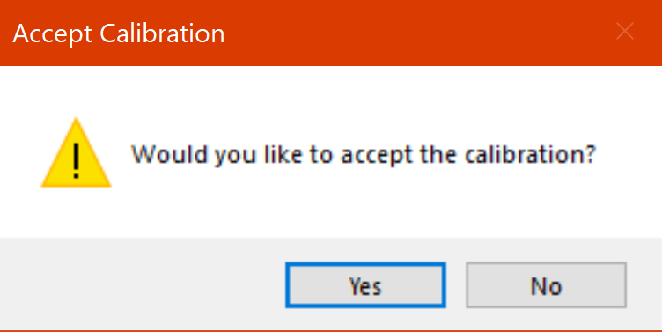

Step 5. Checkbox of excluded wells. A GUI containing a 3x4 pattern of checkboxes will appear prompting the user to select any wells which were excluded. You must click any well which was not manually selected in step 3. If you did not exclude any wells, simply click “done” and select no checkboxes.

In the previous example, the right 6 wells were excluded so the checkbox should look like this

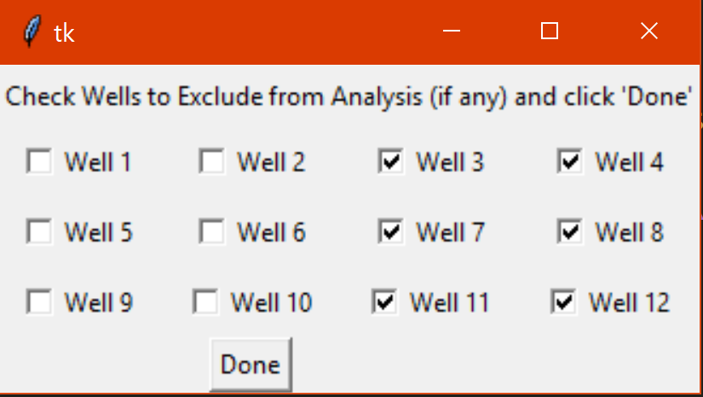

Step 6. Find well centers. Video frame is presented containing 12 circles around the well centers. Click on this image, as it is not selected by the cursor when it is first shown. If all 12 wells have a circle around them, click the “y” key and this image will be saved. If not, click the “n” key and the next frame will appear. This is to match flies to their respective wells. No user input is needed after this step so you can walk away.

An example of all 12 wells found (this should normally happen), so the user would click “y”

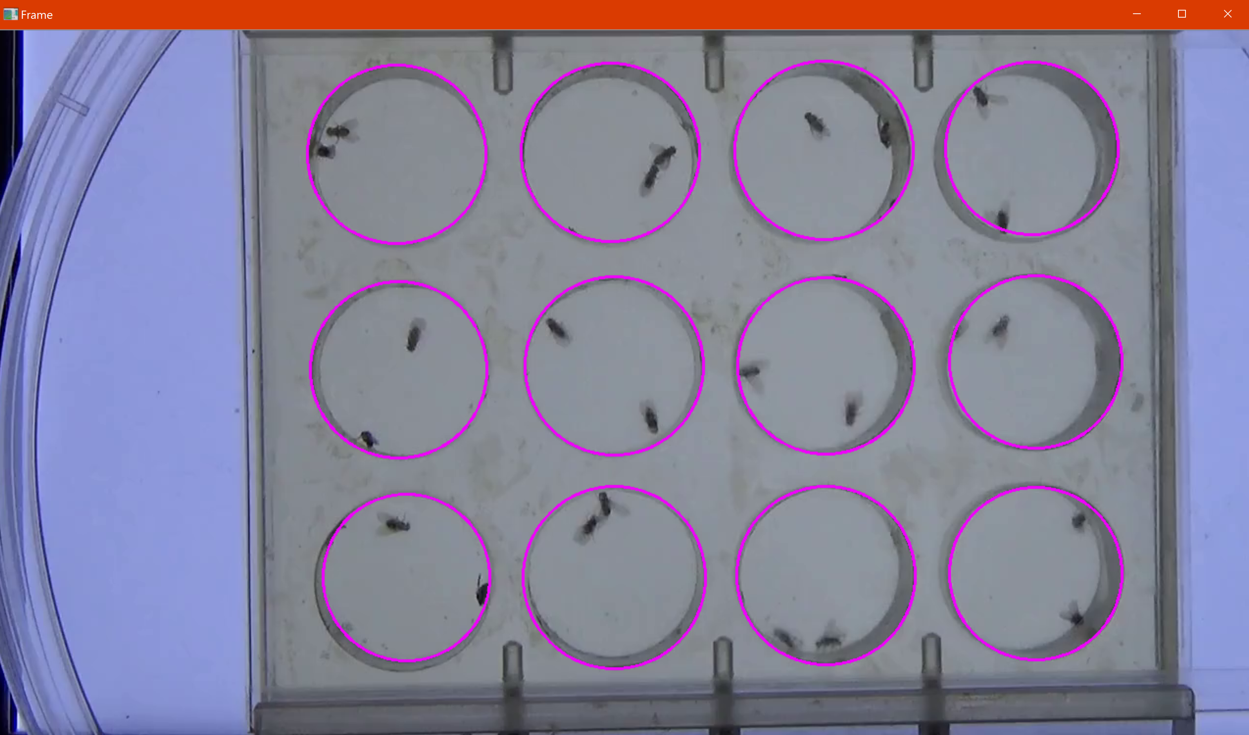

Step 7. Track the video. FlyTracker tracking launches in MATLAB and parses the video into 10 chunks to process the video. This step takes a while, approximately 4-5 hours for a 30-minute video with 24 flies.

Step 8. Prepare files for JAABA. This step moves the file structure such that JAABA can access everything it needs from the tracking step.

Step 9. Classify behavior. JAABA generates per-frame features from the tracking data and applies the LungeV2 classifier Ben trained with a postprocessing hysteresis threshold of 0.57 and a minimum bout length of 2 frames. This data is saved to a file called scores_lungeV2

Step 10. Write output to excel file. The output excel file will be called the video filename_Data.xlsx. The excel notebook consists of two notebooks. The first has each of the 24 flies, what fly ID JAABA gave them, their well position (A being the fly on top in the first frame, B on the bottom, with the wells labeled 1-12 from left to right, top to bottom), whether the fly was excluded from analysis, the distance in mm it travelled, the total number of lunges it performed, and the start of the lunge bouts in frame number and in seconds, and the ends of the bouts in frames. The second sheet has a minute-by-minute breakdown of the number of lunges performed in each 60 second window for each of the 24 flies. Excluded flies have all 0’s here.

Example output images:

Sheet 1

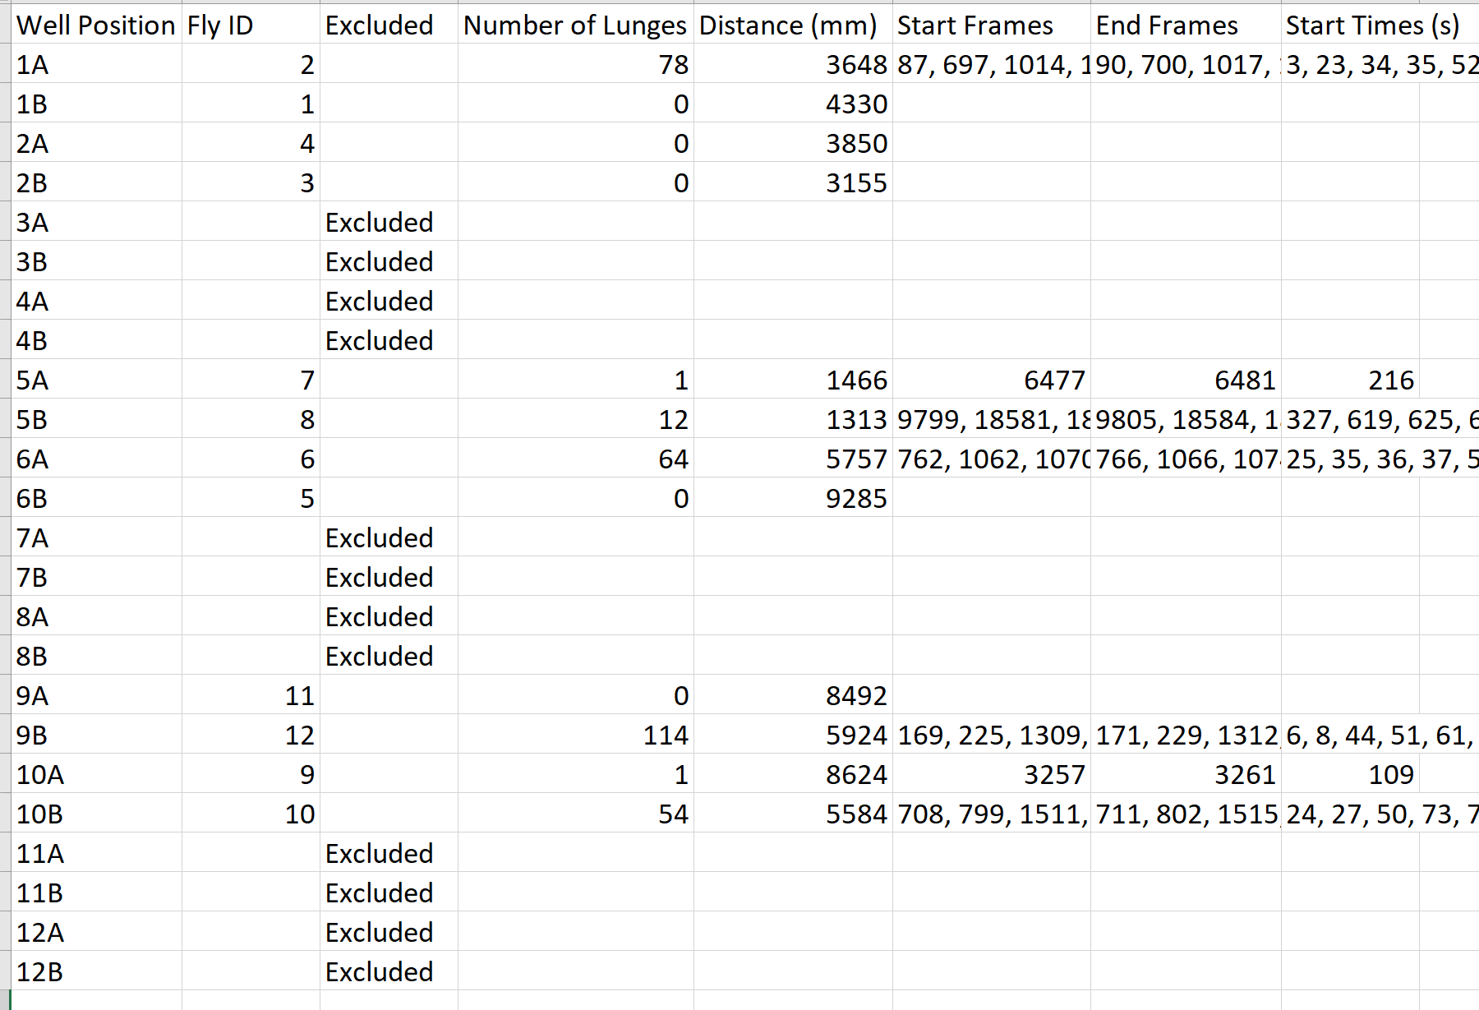

Sheet 2

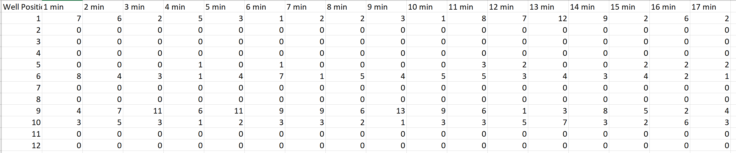

What the folder looks like after the analysis is complete:

